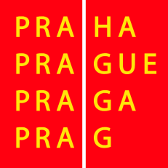
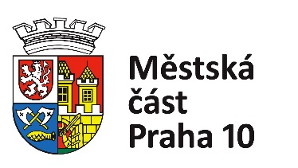

GRAND PRIX FRAMAR 2022 – 80th edition

UCI CL2 International cycling race
Czech Cup in Track Cycling

Sponsors: The City of Prague, Prague 10 Town Hall,
Barvy Framar s.r.o, ŠKODA AUTO, a.s.
Organizer: TJ KOVO Praha

Date: 2nd – 3rd September 2022 GP FRAMAR UCI Cl2

Venue: Třebešín Velodrome, Nad Kapličkou 3324/15, Praha 10, Czech Republic

Coordinates: 50°05'01.7"N 14°29'21.3"E
Velodrome description: Length: 333m, Surface: Concrete, Type: Open-air
Event Type: UCI Class 2
Race Director: Jaroslava Mixová
Contact: e-mail: info@kovopraha.cz
English speaking: Marek Mixa, +420 724116963
Chief Commissaire: Markéta Jandová, marketajandovka@seznam.cz
Categories: Men, Women, juniors
Registration: by e-mail: framar@kovopraha.cz until 28. 8. 2022
Race office: First floor of TJ KOVO building
Race numbers: Thursday 4-6pm, in Race Office
Changing rooms: Ground floor of TJ KOVO building
Accommodation: Provided by organizer for ELITE category (ask for details)
Transport: Organizer can provide help with transport
Medical Care: Maventis s.r.o.
Nearest Hospital: University Hospital Vinohrady, Šrobárova 50, Prague 10, 10034

Regulations: Race will be run according to UCI regulations, Czech Cycling Federation regulations as well as this document. Each rider must submit a valid UCI racing licence. Competitors take part in all races at their own risk.
The event organizer is not liable for any loss or damage to personal property.

Program:

Friday 2. September 2022 GP FRAMAR

10:00 Technical meeting for team representatives in the race office

11:30
Omnium - women
Points race - men
Scratch - men

Saturday 3. September 2022 GP FRAMAR

10:00

Omnium - men
Points race - women
Scratch - women

